Civil war in Georgia

UNSC Resolution: | 1225
Date of adoption: | 28-Jan-1999
Operative paragraph: | 2
Demand number: | 1225.0211

David Siroky

Wording of demand

resume bilateral negotiations after the failure of the Athens meetings of 16-18 October 1998 on confidence building measures, agreements on security and the non-use of force, the return of refugees and displaced persons and economic reconstruction

List of addressees of the demand

Government of Georgia, Abkhazia

Short-term compliance

Description of the addressee(s)’ conduct

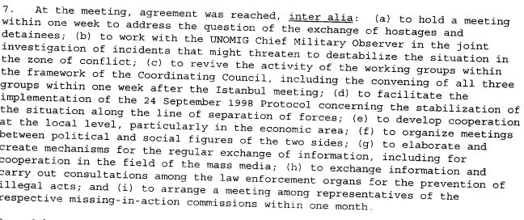s/1999/805

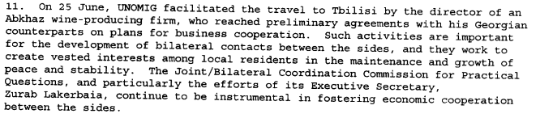
s/1999/805

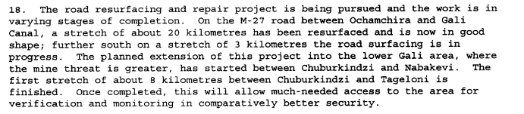
s/1999/805

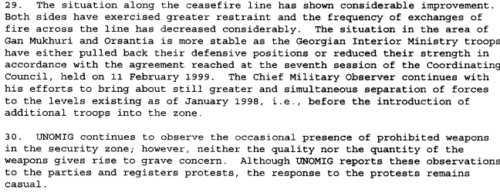
s/1999/805

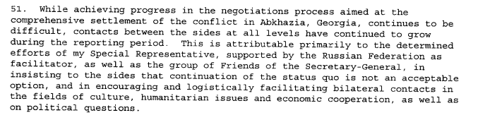
s/1999/805

Assessment

Short-term compliance
No or marginal compliance (1) | Medium low compliance (2) | Medium high x3 compliance (3)

Considerations underlying the assessment

Medium-term compliance

Description of the addressee(s)’ conduct

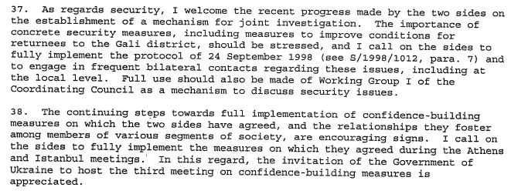s/2000/39

Assessment

Medium-term compliance
No or marginal compliance (1) | Medium low compliance (2) | Medium high x3 compliance (3)

Considerations underlying the assessment

Depth of demand

Assessment

Level of depth of demand
Low depth of demand (1) | Medium depth of demand (2) x2

Considerations underlying the assessment

Level of confidence about coding decisions
Level of confidence about coding decision
Extremely high | High x

Comments to IPI (if any)

Civil war in Georgia

UNSC Resolution: | 1225
Date of adoption: | 28 January 1999
Operative paragraph: | 3
Demand number: | 1225.0311

David Siroky

Wording of demand
Government of Georgia, Abkhazia

List of addressees of the demand

widen commitment to the UN-led peace process, continue to seek and engage in dialogue, expand contacts with opposing side at all levels and display without delay the necessary will to achieve substantial results on the key issues of the negotiations and achieve an early and comprehensive political settlement, which includes a settlement on the political status of Abkhazia within the State of Georgia, which fully respects the sovereignty and territorial integrity of Georgia within its internationally recognized borders

Short-term compliance

Description of the addressee(s)’ conduct

The eighth session of the Coordinating Council of the Georgian and Abkhaz sides, chaired by my Special Representative, was held on 29 April 1999. As at previous sessions, the Georgian delegation was led by State Minister Vazha Lordipanidze, and the Abkhaz delegation by the de facto Prime Mnister, Sergei Bagapsh. [The Council decided to work together on a number of issues, including reinvigorating the activities of its three working groups; to continue bilateral talks on the creation of favorable conditions for refugee returns. (S-G’s Report, July 1999)

As part of the Geneva process, my Special Representative convened a meeting of the Georgian and Abkhaz sides on confidence-building measures, from 7 to 9 June. (S-G’s Report, July 1999)

The two meetings on confidence-building measures held to date, in Athens and in Istanbul (June 1999), were successful in providing a forum for both the development of direct bilateral ties at several levels of society and the elaboration of concrete project for cooperation. (S-G’s Report, July 1999)

During the reporting period, issues related to the settlement of the confliuct in Abkhazia, Georgia, were also discussed by representatives of the Georgian side with a number of foreign leaders and officials in the framework of bilateral contacts, as well as in international forums, including the CIS, NATO, and the council of Europe. (S-G’s Report, July 1998)

Assessment

Short-term compliance
No or marginal compliance (1) | Medium low compliance (2) | Medium high compliance (3) | Full or almost full compliance (4)

Considerations underlying the assessment

Medium-term compliance

Description of the addressee(s)’ conduct

Since he assumed his duties, my Special Representative has met with the President of Georgia, Eduard Shevardnadze, Abkhaz leader Vladislav Ardzinba, and the Minster for Foreign Affairs of the Russian Federation, Igor Ivanoc. All these interlocutors pledged to support him in his efforts towards reinvigorating the peace process. They also expressed their readiness to work simultaneously on several key issues, including preparing the ground for a comprehensive political settlement, including the political status of Abkhazia, Georgia. (S-G’s Report, January 2000)

During the meetings, there was general agreement on the need to make full use of the existing machinery of the peace process. Subsequently, the negotiating process was resumed on 18 and 19 January 2000, after a nine-month hiatus, when the ninth session of the Coordinating Council of the Georgian and Abkhaz sides was convened at Tbilisi under the chairmanship of my Special Representative. (S-G’s Report, January 2000)

At the invitation of the Government of Ukraine, a third high-level Meeting on Confidence-building Measures was originally to have been convened in Yalta, Ukraine, at the end of November. However, disagreements between the Georgian and Abkhaz sides regarding its agenda and a concluding document necessitated further consultations (January, 2001)

In November, my Special Representative visited Moscow for consultations. Despite his efforts there and numerous top-level meetings with the parties to the conflict, no substantive progress was made on the draft document for the distribution of competencies between Tbilisi and Sukhumi. Meanwhile, the Abkhaz side continues to refuse to discuss any document that would address the status issue. (S-G’s Report, January, 2001)

Assessment

Medium-term compliance
No or marginal compliance (1) | Medium low compliance (2) | Medium high compliance (3) | Full or almost full compliance (4)

Considerations underlying the assessment

Depth of demand

Assessment

Level of depth of demand
Low depth of demand (1) | Medium depth of demand (2) | High depth of demand (3)

Considerations underlying the assessment

Level of confidence about coding decisions

Level of confidence about coding decision
Extremely high | High | Moderate

Comments to IPI (if any)

Civil war in Georgia

UNSC Resolution: | 1225
Date of adoption: | 28-Jan-1999
Operative paragraph: | 6
Demand number: | 1225.0611

David Siroky

Wording of demand

observe strictly the Moscow Agreement (S/1994/583, annex I) and also the ceasefire protocol signed on 25 May 1998, as well as all their obligations to refrain from the use of force and to resolve disputed issues by peaceful means only in addition to display greater resolve and willingness to make the Joint Investigation Group functional

List of addressees of the demand

Government of Georgia, Abkhazia

Short-term compliance

Description of the addressee(s)’ conduct

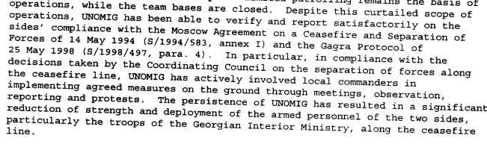
s/1999/805

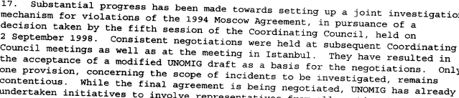
s/1999/805

s/1999/805

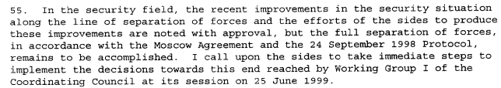
s/1999/805

Assessment

Short-term compliance
No or marginal compliance (1) | Medium low compliance (2) | Medium high x3 compliance (3)

Considerations underlying the assessment

Medium-term compliance

Description of the addressee(s)’ conduct

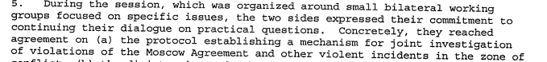s/2000/39

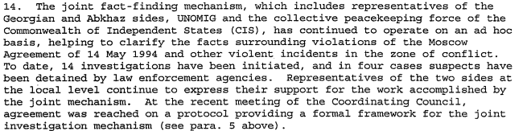s/2000/39

s/2000/39

s/2000/39

Assessment

Medium-term compliance
No or marginal compliance (1) | Medium low compliance (2) | Medium high x3 compliance (3)

Considerations underlying the assessment

Depth of demand

Assessment

Level of depth of demand
Low depth of demand (1) | Medium depth of demand (2) x2

Considerations underlying the assessment

Level of confidence about coding decisions
Level of confidence about coding decision
Extremely high | High x

Comments to IPI (if any)

Civil war in Georgia

UNSC Resolution: | 1225
Date of adoption: | 28-Jan-1999
Operative paragraph: | 7
Demand number: | 1225.0711

David Siroky

Wording of demand

address the situation of refugees and displaced persons, resulting most recently from the hostilities of May 1998, in the context of the Quadripartite Agreement (S/1994/397 Annex II) urgently by agreeing and implementing effective measures to guarantee the security of those who exercise their unconditional right to return

List of addressees of the demand

Government of Georgia, Abkhazia

Short-term compliance

Description of the addressee(s)’ conduct

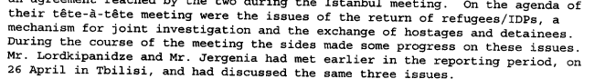
s/1999/805

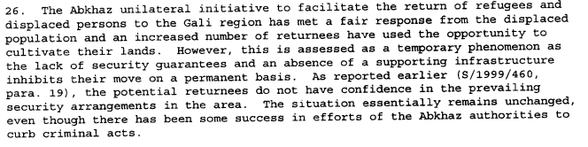s/1999/805

s/1999/805

Assessment

Short-term compliance
No or marginal compliance (1) | Medium low compliance (2) x2 | Medium high compliance (3)

Considerations underlying the assessment

Medium-term compliance

Description of the addressee(s)’ conduct

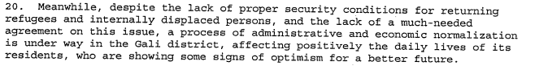
s/2000/39

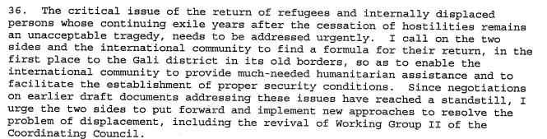
s/2000/39

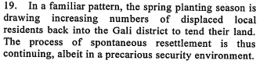
s/2000/345

Assessment

Medium-term compliance
No or marginal compliance (1) | Medium low x2 compliance (2) | Medium high compliance (3)

Considerations underlying the assessment

Depth of demand

Assessment

Level of depth of demand
Low depth of demand (1) | Medium depth of demand (2) x3

Considerations underlying the assessment

Level of confidence about coding decisions
Level of confidence about coding decision
Extremely high | High x

Comments to IPI (if any)

Civil war in Georgia

UNSC Resolution: | 1225
Date of adoption: | 28-Jan-1999
Operative paragraph: | 8
Demand number: | 1225.0811

David Siroky

Wording of demand

resume and intensify bilateral dialogue to facilitate the safe return of refugees and displaced people to the Gali region, as a first step

List of addressees of the demand

Government of Georgia, Abkhazia

Short-term compliance

Description of the addressee(s)’ conduct

s/1999/805

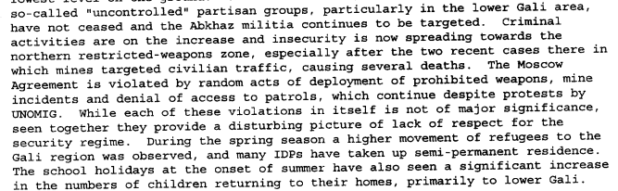s/1999/805

s/1999/805

s/1999/805

Assessment

Short-term compliance
No or marginal compliance (1) | Medium low x2 compliance (2) | Medium high compliance (3)

Considerations underlying the assessment

Medium-term compliance

Description of the addressee(s)’ conduct

s/2000/39

s/2000/39
s/2000/345

Assessment

Medium-term compliance
No or marginal compliance (1) | Medium low x2 compliance (2) | Medium high compliance (3)

Considerations underlying the assessment

Depth of demand

Assessment

Level of depth of demand
Low depth of demand (1) | Medium depth of demand (2) x2

Considerations underlying the assessment

Level of confidence about coding decisions
Level of confidence about coding decision
Extremely high | High x

Comments to IPI (if any)

Civil war in Georgia

UNSC Resolution: | 1225
Date of adoption: | 28-Jan-1999
Operative paragraph: | 10
Demand number: | 1225.1011

David Siroky

Wording of demand

take immediate and determined measures to put a stop to acts, including the continued laying of mines, especially in the Gali region, and ensure that the security environment of all international personnel improves significantly

List of addressees of the demand

Government of Georgia, Abkhazia

Short-term compliance

Description of the addressee(s)’ conduct

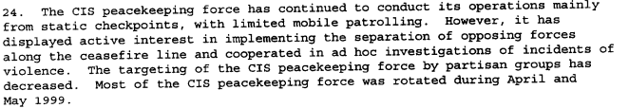
s/1999/805

s/1999/805

s/1999/805

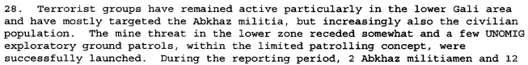
s/1999/805

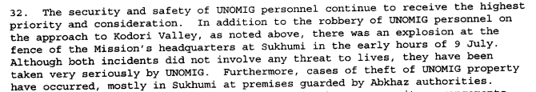s/1999/805

Assessment

Short-term compliance
No or marginal compliance (1) | Medium low compliance (2) x2 | Medium high compliance (3)

Considerations underlying the assessment

Medium-term compliance

Description of the addressee(s)’ conduct

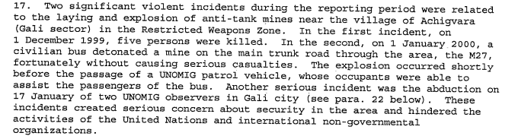
s/2000/39

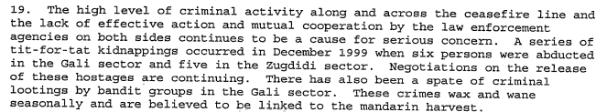s/2000/39
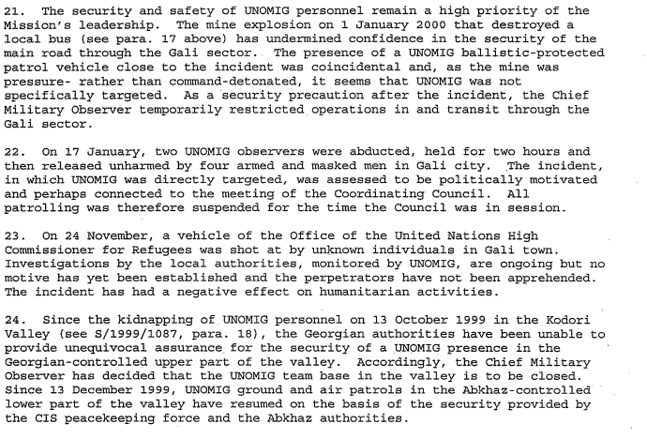
s/2000/39

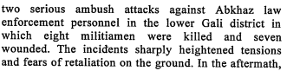
s/2000/345

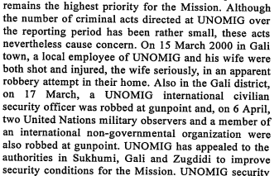
s/2000/345

Assessment

Medium-term compliance
No or marginal compliance (1) x1 | Medium low compliance (2) | Medium high compliance (3)

Considerations underlying the assessment

Depth of demand

Assessment

Level of depth of demand
Low depth of demand (1) | Medium depth of demand (2) x2

Considerations underlying the assessment

Level of confidence about coding decisions
Level of confidence about coding decision
Extremely high | High x

Comments to IPI (if any)

